BRAC UNIVERSITY
Department of Computer Science and Engineering

Examination: Semester Midterm  Duration: 1 hour 10 min | Semester: Summer 2023  Full Marks: 30
CSE 320: Data Communications

Answer the following questions.
Figures in the right margin indicate marks.

SET B

Name: | ID: | Section:

1.  [CO1] | a) | Suppose there are 4 buildings in BRACU’s new campus. Buildings are connected using bus topology. Each building has 3 CSE Labs. Each Lab has 4 computers. The computers are connected using star topology but the Labs of a single building are connected using mesh topology. Draw the BRACU new campus hybrid topology. How many links will there be (links are using full-duplex transmission mode)? | [5]
 | b) | Identify the name of the TCP/IP model layers based on the following functionalities.  - Determines the logical address of the destination device.  - Ensures no unintended party can eavesdrop on the data being transmitted.  - Prevents traffic congestion between a device and its neighbouring hop.  - Ensures that data is received by the correct process among many processes running on the destination host. | [2]
 | c) | What characteristics does the effectiveness of data communication depend on? Describe how the sender and receiver use the capacity of the channel in simplex, half-duplex and full-duplex mode. | [3]
2.  [CO2] | a) | 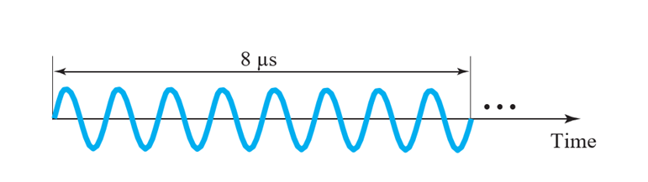  Figure 2.a: Analog Signal (time Vs Amplitude)  In the above Figure 2.a, determine the time period and frequency of the analog signal. Also show the frequency domain representation of the signal if the maximum amplitude is 15V. | [3]
 | b) | Suppose the signal power is 6 MW at point A. The power loss rate at the wire from A to B is 3 kW/km and from C to D is 0.04 dB/km. Calculate the total change of signal power in decibel and comment if the power is being amplified/attenuated.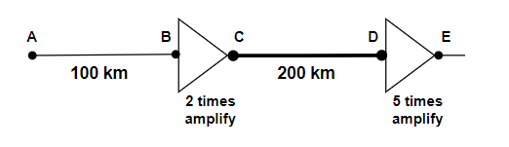 | [3]
 | c) | Consider a communication channel that requires to send 108 GB within 8 hours. The link operates on signals with frequency range from 800 KHz to 13 MHz. If the link is perfect, i.e., no noise is introduced in the link,  - Determine the number of voltage levels needed to fulfill the requirement.  - In practice, there is no noise free channel. Suppose, the strength of the noise power is 30mW which is 20 times weaker than the signal power. What will be the channel capacity considering the noise? | [2+2]
3.  [CO2] | a) | Two devices A and B are sending digital signals using the NRZ-I-line coding scheme. Device C is receiving the signal simultaneously and combining them using bitwise OR operation. Then produces the final digital signal using a line coding scheme that doesn’t have the long sequence of 1 problem. Illustrate the final signal produced by C. [You can use any valid line coding scheme for C] [Draw it in the question paper only.]  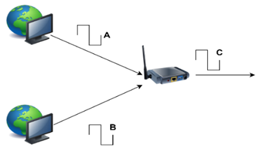  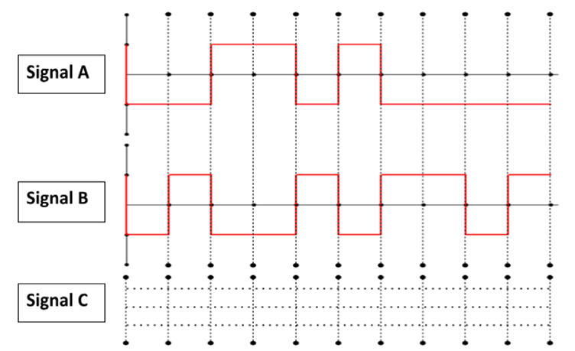 | [5]
 | b) | The following figure depicts a sampled analog signal for digital signal representation. By applying the concept of Pulse Code Modulation, assume there will be 3-bit code words for each sampled amplitude. Show the normalized quantized value and quantization code for the given analog signal value at different time stamps. Assume that the sampling amplitudes are between -20V to +20V.  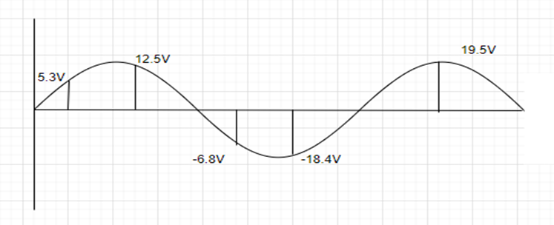 | [5]


